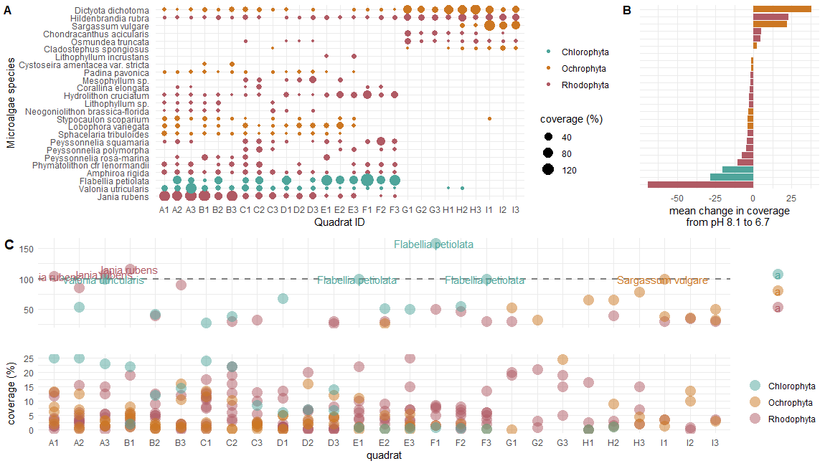

Fig 1. Macroalgae species amounts (% coverage) from each sampled quadrat **(A)** demonstrate that several species of macroalgae are absence from the most acidic environments (e.g. Jania rubens, Valonia utricularis, Flabellia petiolate) and new species arise (e.g. Dictyota dichotoma, Hildenbrandia rubra, Sargassum vulgare) **(B).** Several of the values that correspond with the most significant changes in coverage are highly abundant prior to becoming completely absent **(C)**.

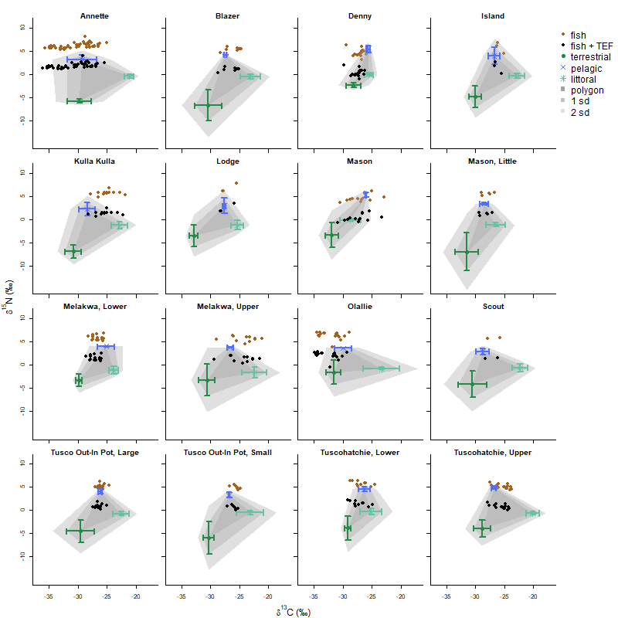

Fig 2. Data used in mixing models for each lake show the mean (± SD) of the carbon and nitrogen stable isotope ratios for terrestrial, pelagic, and littoral basal resources. The points show the stable isotope ratios of fish prior to (brown) and after (black) adjusting with trophic enrichment values from Bunn 2013.

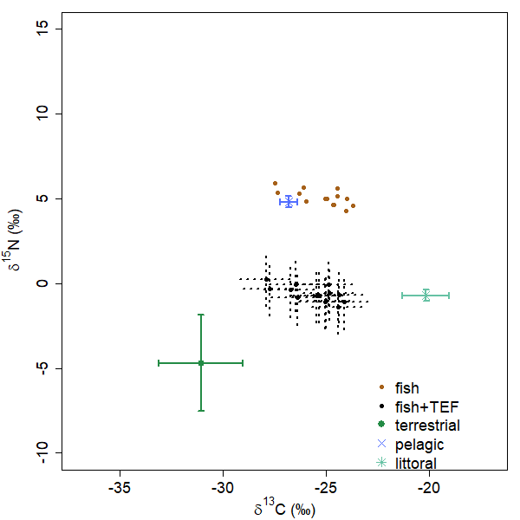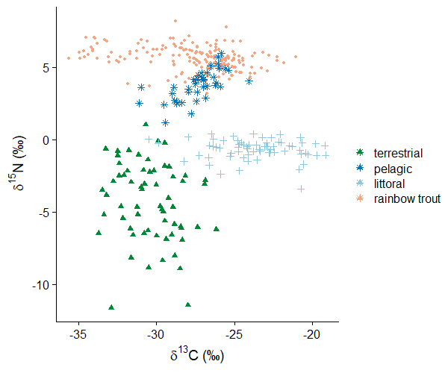

Fig 3. Base vs ggplot2 single isotope by plots.

Figure 4.Light profile plots from 16 lakes